1. Wmic memorychip get banklabel, capacity, speed, manufacturer
2. 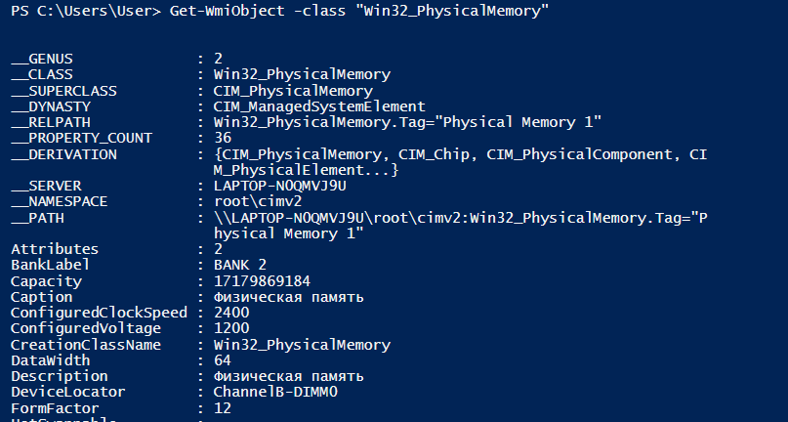

Get-WmiObject -class "Win32_PhysicalMemory"

1. 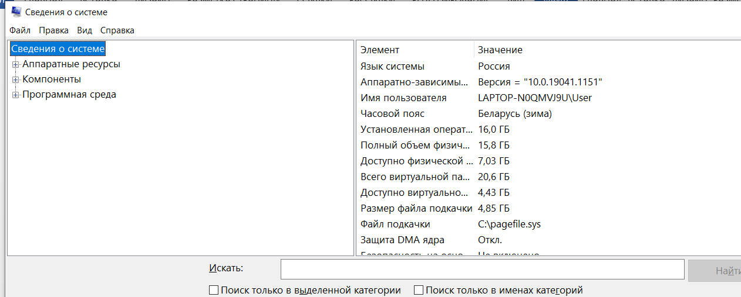
2. 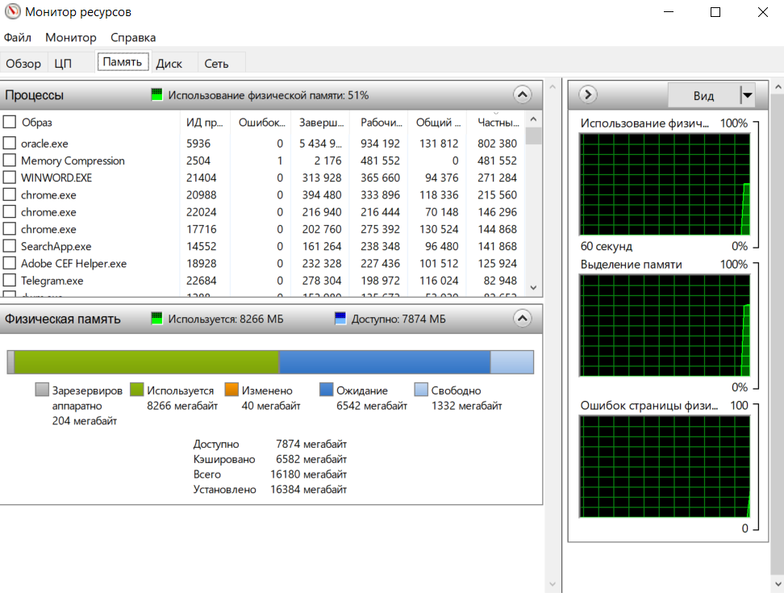
3. 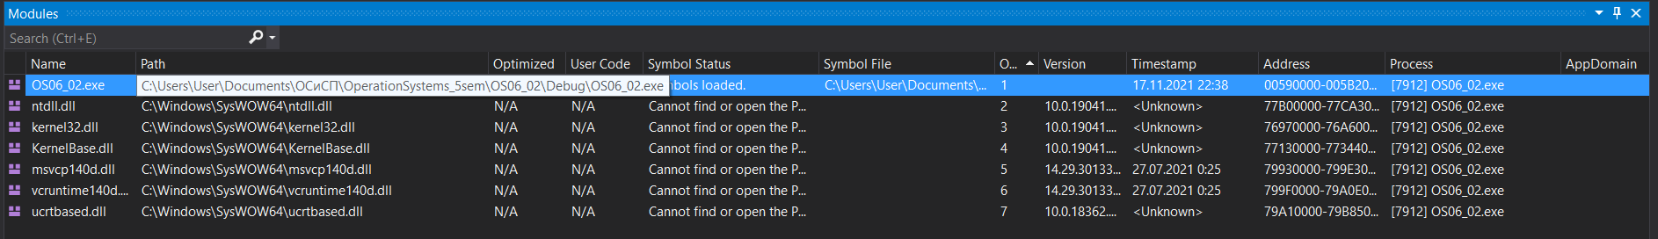
4. 